Department of Veteran Affairs (DVA):
Prescription Drug coverage:
www.veterans.gc.ca/eng/services/health/treatment-benefits/poc#poc10
Veteran Affairs Canada (VAC) formulary:
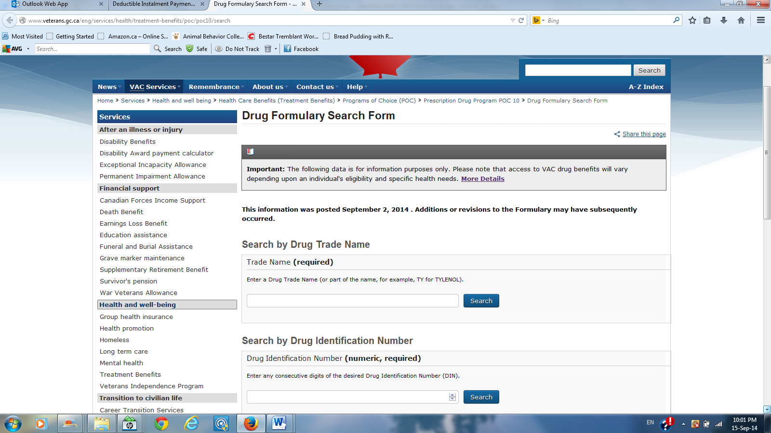
www.veterans.gc.ca/eng/services/health/treatment-benefits/poc/poc10/search
Can find the pseudo-DINs needed for billing of the various diabetes products such as strips, lancets, pen needles etc.

